supply Chain Resilience Improved by Blockchain

The logistics and supply chain management (SCM) field recently went through unprecedented disruptions, thanks to the development of information and communications technologies, (ICTs) Blockchain is one of these disruptive ICTs, that could have huge impacts on operations, supply chain and business models that facilitate the execution of smart contracts between supply chain stakeholders. Indeed, blockchain technologies allow the digitalization of decentralized business models through the “implementation of autonomous algorithmic trust controls for decentralized systems”

Blockchain technologies have the potential to transform almost all SCM business models, enhance end-to-end supply chain business processes and thus improve supply chain performance. Also, blockchain could facilitate the access to product or service, thereby influencing customer perceived value of the said product or service.

Considering the blockchain tamper-proof characteristic and the impact it may create in logistics and supply chain the level of blockchain adoption in this field is expected to increase significantly in order to enhance supply chain performance. Amongst other advantages, blockchain technologies can improve complex supply chain problems (e.g., product safety, supply chain visibility, transparency, etc.), and enhance the traceability of operations, irrespective of the area.

Supply chain performance plays a critical role in all types of organizations and attaining such performance has been rendered more difficult by the increased complexity of operations in the digital age. With the integration of blockchain, we deemed it necessary to map the gaps and enable a better understanding of the relationship between blockchain and supply chain performance.

For instance, blockchain technologies lead to real-time traceability, improved transparency between supply chain members, reduced risks of counterfeiting and more efficiency in supply chain processes.

A particular concern has been focused on how digitalization and data analytics capabilities can be manifested in predicting future

and identifying real-time events. A trend towards digital twins, i.e. computerized models that represent a physical object in real time. One of the substantive areas of data analytics and digital twin applications is SC disruption.

SC risk managers are interested in decision-making support to identify disruption scenarios, to understand the proneness to disruptions of certain parts of the network and fortify them, to monitor and recognize the disruptions in real time, and to determine the actions for the time of disruption and recovery.

The existing optimization and simulation models provide a decision-making support for stress-testing of the existing SC designs and for the deployment of contingency and recovery plans. These models need data on disruptions which happened in the past to construct disruption scenarios, and real-time data on disruptions to timely identify bottlenecks and to deploy the recovery policies.

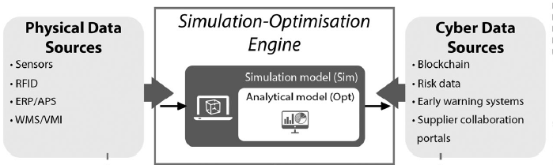

For a resilience supply chain, acquiring and sharing real-time information is of vital importance for SC recovery planning and the coordinated deployment of recovery policies. Tracking and tracing (T&T) systems aim to identify deviations or danger of deviations in SCs, analyze those deviations and deliver actual or potential disruption alerts, and elaborate control actions in order to recover SC operability. In combination with RFID (radio-frequency identification) and mobile devices, these systems are used to provide current information about process execution. In addition, blockchain applications to SCs, the creation of information pipeline systems, and SC finance systems are becoming more and more important for enhancing the scale and scope of T&T systems. The central idea behind these applications is to increase visibility and efficiency based on record-keeping in the SC. For example, IBM and Wal-Mart are currently researching how they can increase food SC safety controls using blockchain technology.

Source:

(1) Dynamics between blockchain adoption determinants and supply chain performance: An empirical investigation. Samuel Fosso Wamba a,\*, Maciel M. Queiroz b, Laura Trinchera. International Journal of Production Economics

(2) A digital supply chain twin for managing the disruption risks and resilience in the era of Industry 4.0. Dmitry Ivanova and Alexandre Dolguib. Production planning & control <https://doi.org/10.1080/09537287.2020.1768450>